**Technical Exercise (SEO Analyzer)**

**Task description**

Implement simplified SEO Analyser: web application that performs a simple SEO analysis of the text. User submits a text in English or URL, page filters out stop-words (e.g. ‘or’, ‘and’, ‘a’, ‘the’ etc), calculates number of occurrences on the page of each word, number of occurrences on the page of each word listed in meta tags, number of external links in the text.

**Development & other tools used**

* Microsoft Visual Studio 2017
* Do Net Framework 4.6.1
* C# Dot Net
* MVC Framework
* jQuery
* LINQ
* Datatable.js (using CDN)
* Unit Testing

**Solution & Projects**

* SEO - executable project
* CommonServices - services to validate the html contents against the analysis criteria ( calculates number of occurrences on the page of each word, number of occurrences on the page of each word listed in meta tags, number of external links in the text)
* SEO.Tests - unit testing project to perform testing on the functions

**Screens & Description**

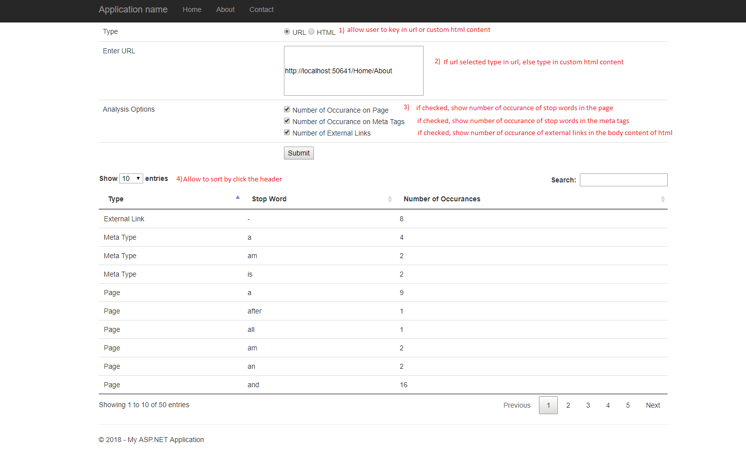

**Figure 1: SEO Analyzer screen**

* This is the SEO search screen that allow user to search the site / custom html contents against the analysis options available.
* User allowed to search using URL or custom HTML by clicking the radio button as in (1)
* After selected the type to search, user can type in URL or custom HTML inside the textbox as in (2)
* User allowed to customize their analysis option to show inside the output table as in (3). The system only allow user to search for number of occurrence of stop words in page, number of occurrence of stop words in the meta tags and number of occurrence of external links inside the URL or custom HTML.
* The output table allow user to perform ordering, searching & paging as in (4). This feature done by using Database.js.

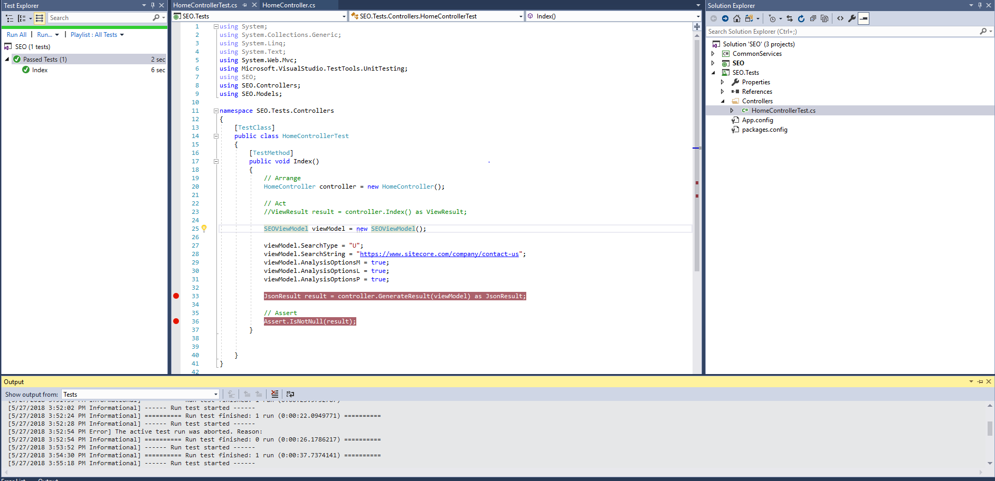**Figure 2: Unit testing output**

* Figure 2 shows the sample testing result of the page using unit testing provided in Visual Studio.

**Execute the program**

* You just need to download the source code from provided GitHub account link.
* Open the SEO.sln file inside the folder and built the solution.
* After that, the SEO analyzer page will be shown as in Figure 1: SEO Analyzer screen. (Default path: localhost/Home/Index).

**Documentation by:** **Chan Yung Lin**

**Date: 27 May 2018**